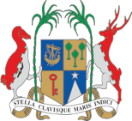
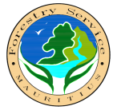
Ministry of Agro-Industry and Food Security
COMMUNIQUE
Sale of Pine Christmas Trees
1. The public is informed that Pine Christmas trees will be put on sale by the Forestry Service at Rs200/- per unit on the dates, time and sale points listed below:

Sales Point | Date | Time
Forestry Service, Headquarters, Botanical Garden Street, Curepipe  Tel 674-0481 | Monday 20 December  Tuesday 21 December Wednesday 22 December  Thursday 23 December Friday 24 December | 08.00 hours  to  15 00 hours
Abercrombie Nursery, Abercombie, Port Louis
Tel 241-0581/240-0006

Quartier Militaire Forest Office (Near Police Station)
Tel 435-5545

Souillac Forest Nursery,
Chaine Street, Souillac
Tel 625-6319

Pamplemousses Forest Office, Near SSRN Hospital
Tel 243-8874

2. One “Araucaria” plant in small polythene bag will be offered free of charge for each pine Christmas tree purchased.

3. For any further information/clarification, the Forestry Service may be contacted on Tel No: 671-7254 or 675-4968 and Fax No 674 -3449.

Ministry of Agro-Industry and Food Security
9th Floor, R. Seeneevassen Building
Cnr Jules Koenig & Maillard Streets
Port Louis
Tel 212 0854 14 December 2021

