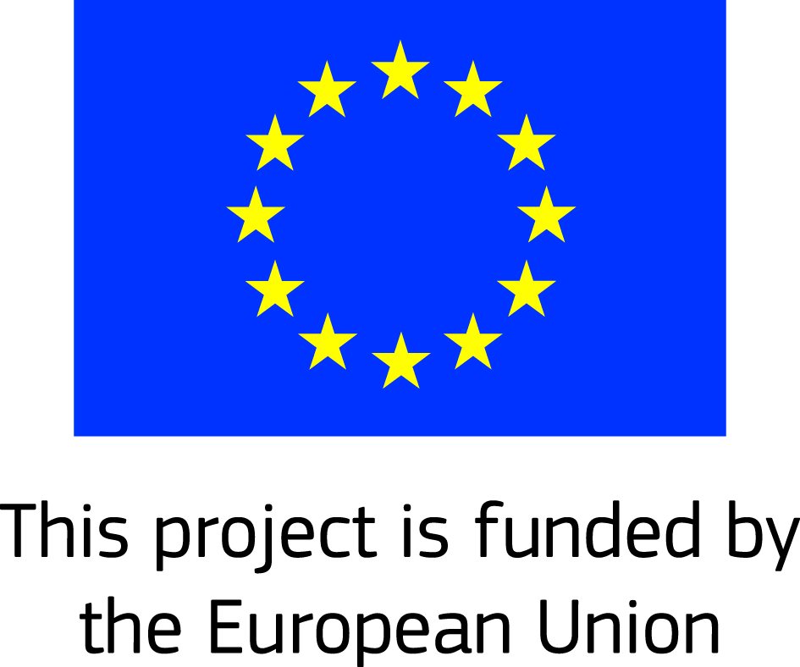

IRRIGATION AUTHORITY

PROCUREMENT NOTICE
(Authorised under Section 16 of the Public Procurement Act 2006)

Open National Bidding

GCCA+ FLAGSHIP INITIATIVE
“Supporting Climate Smart Agriculture for Small Holders in the Republic of Mauritius”

CONSULTANCY SERVICES FOR IMPROVING RESILIENCE OF SMALL HOLDERS TO THE EFFECT OF CLIMATE CHANGE

Procurement Reference No: RFP/CC/EU/IPU 20/01

- The Irrigation Authority invites proposals from qualified national Consultant/Consulting Firms to provide consulting services for improving resilience of small holders to the effect of climate change under this Request for Proposal (RFP) in the context of GCCA+ Flagship Initiative “Supporting Climate Smart Agriculture for Small Holders in the Republic of Mauritius”.

- The bidding document can be downloaded from Procurement Policy Office Portal http://publicprocurement.govmu.org

- The pre-meeting/site visit will be held on Tuesday 17 March 2020 at 10 00 hours at the sub-office of the Irrigation Authority at Plaines des Papayes.

- Bids must be deposited in the Tender Box situated at the address below on or before Tuesday 07 April 2020 by 15h30 at latest. Electronic bidding shall not be permitted. Late bids will be rejected. Bids will be opened in the presence of the bidders’ representatives who choose to attend in person at the address below at 16h00 on Tuesday 07 April 2020.

- The address referred to, in paragraph 4 above, is:
Irrigation Authority
5th Floor Fon Sing Building,
12, Edith Cavell Street,
Port Louis
Tel. 210-6596
Fax No. 212-7652
Email irrig@irrig.org

6. The Irrigation Authority may, at any time prior to the acceptance of a bid, reject all bids, or cancel the procurement proceedings without thereby incurring any liability to any bidder.

28 February 2020

