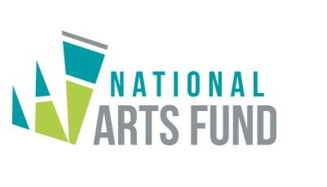
FIFTH CALL FOR PROJECTS – February 2020

National Arts Fund
The National Arts Fund has been established under the Finance and Audit (National Arts Fund) Regulations 2017, to contribute to the financing of creative arts projects/ programmes with a view to empowering artists, arts practitioners and arts organisations in the different fields of arts and culture.

Arts Grant Schemes
In line with its aims and objectives, the National Arts Fund has designed four Arts Grant Schemes, namely, (i) Emerging Talents Grant Scheme; (ii) Production Grant Scheme; (iii) Capacity Building Grant Scheme; and (iv) Research Grant Scheme.

Call for Projects
The National Arts Fund is launching its fifth call for projects under the Emerging Talents Grant, Production Grant and Research Grant Schemes.
Applications under the Capacity Building Grant Scheme can be submitted throughout the year.

Application Forms and Guidelines
Application forms and Guidelines for applicants are available at the National Arts Fund office, 1st Floor, Renganaden Seeneevassen Building, Cnr Pope Hennessy and Maillard Streets, Port Louis and on the website http://culture.govmu.org

Closing Date
Application forms for the Emerging Talents Grant, Production Grant and Research Grant Schemes together with all relevant documents, should be submitted to the National Arts Fund, Ministry of Arts and Cultural Heritage, 1st Floor, Renganaden Seeneevassen Building, Cnr Pope Hennessy and Maillard Streets, Port Louis by Friday, 20 March 2020 at 15 00 hrs at latest. Applications received after the deadline, not made in the appropriate form and incomplete applications will not be considered.

- Application forms under the Capacity Building Grant Scheme along with all relevant documents should be submitted at least four weeks before the start of the project.

- For any additional information, applicants may wish to contact the National Arts Fund, on telephone number 210-2890 during working hours or by email to nationalartsfund@gmail.com

National Arts Fund
1st Floor, R. Seeneevassen Building

Cnr. Pope Hennessy and Maillard Streets 28 February 2020 Port Louis

