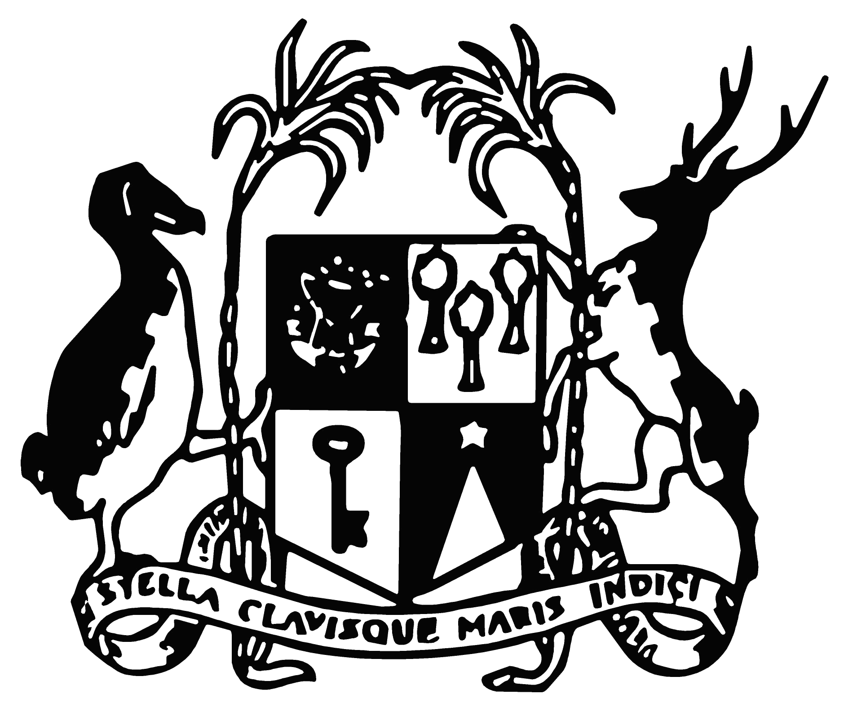

MINISTRY OF FINANCE, ECONOMIC PLANNING AND DEVELOPMENT
Government House, Port Louis, Mauritius

COMMUNIQUE

Wage Assistance Scheme and Self-Employed Assistance Scheme
for the month of April 2021

The Wage Assistance Scheme and the Self-Employed Assistance Scheme have been extended for the month of April 2021 as follows –

A. Tourism Sector

Operators in the Tourism Sector in Mauritius and Rodrigues will benefit from a full month of financial assistance under the Wage Assistance Scheme and the Self-Employed Assistance Scheme.

B. Other Sectors

A full month of financial support will be provided under the Wage Assistance Scheme to Small and Medium Enterprises operating in the Island of Mauritius.

An eligible Self-Employed person working in the Island of Mauritius will also be granted a full month of financial support under the Self-Employed Assistance Scheme.

Under the Wage Assistance Scheme, all employees drawing a monthly basic wage of up to Rs 50,375 are eligible to an allowance equivalent to one-month basic wage up to a maximum of Rs 25,375.

Under the Self-Employed Assistance Scheme, the monthly allowance payable is Rs 5,287.

10 April 2021

