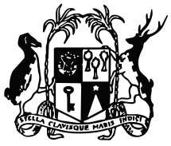

MINISTRY OF ENVIRONMENT, SOLID WASTE MANAGEMENT AND CLIMATE CHANGE
PROCUREMENT NOTICE
COMMUNIQUE

Supply and Installation of Rainwater Harvesting System in Schools around the Island

Procurement Reference No: ENV/OAB/03/2020

Bidders are hereby informed that due to lockdown, the new deadline for submission of bids for the abovementioned procurement is 17 June 2020 at 13.30 hours.
2. Bids in a sealed single envelope, clearly marked ENV/OAB/03/2020 addressed to The Permanent Secretary, Ministry of Environment, Solid Waste Management and Climate Change should be deposited in the Quotation Box located at 9th Floor, Ken Lee Tower, Cnr Barracks & St George Streets, Port Louis.

Ministry of Environment, Solid Waste Management and Climate Change
9th Floor, Ken Lee Tower,
Cnr Barracks & St Georges Streets, Port Louis
Tel: 230 203 6200
Fax: +230 210 0828

04 June 2020

