Press Release
Environmental Monitoring following shipwreck of MV Wakashio Vessel
- Coastal Water Quality Monitoring

- Following the grounding of the MV Wakashio on Saturday 25 July 2020 at around 19.30 hours, the Ministry of Environment, Solid Waste Management and Climate Change (MOESWMCC) has promptly initiated various actions including environmental monitoring of our terrestrial and marine resources.

- Although there was no visible sign of oil spill, seawater samples were collected on Sunday 26 July 2020 by the National Environmental Laboratory (NEL) of the MOESWMCC from Pointe d’Esny to Blue Bay. Samples were analysed for various parameters including Oil/Grease and Total Hydrocarbons. All the sites monitored complied with the recommendations of Guidelines for Coastal Water Quality (Class A1 for Conservation) of the Environment Protection Act.

- As from 26 July 2020, a daily coastal water quality monitoring program was established by NEL. The Albion Fisheries Research Centre (AFRC) also collected seawater samples and sediments from the lagoon for regular monitoring.

- The presence of Oil/Grease and Total Hydrocarbons was first detected on 6 August 2020 at Mahebourg and Pointe Jerome, the date on which oil spill from MV Wakashio was reported.

- As from 7 August 2020, an integrated monitoring programme was set up among NEL, AFRC and Mauritius Oceanography Institute (MOI) for the affected sites. The number of coastal sites monitored was increased to twenty seven sites (27) covering the regions from La Cambuse to Trou D’eau Douce.

- The AFRC and MOI are also conducting ecological surveys using rapid assessment techniques to assess the impact of the oil spill on the ecosystems in the affected areas.

- Graphical presentation of the evolution of oil/Grease and Total Hydrocarbon levels in seawater at Riviere des Creoles, one of the most affected sites, is shown below:
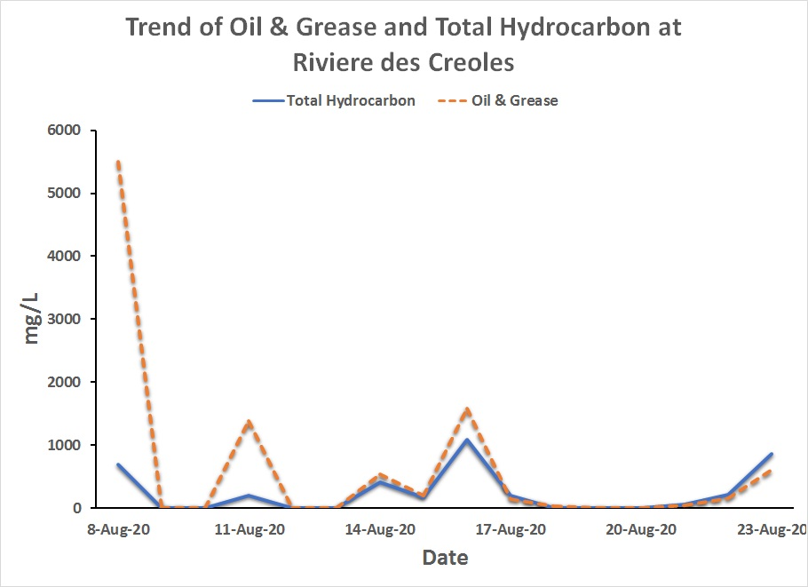
Note: As per guidelines for Coastal Water Quality (Class A1 for Conservation) of the Environment Protection Act Oil/Grease must not detectable by N-Hexane Extraction Method in sea water
- Continuous monitoring to date has shown that there has been a significant decrease in level of Oil and Grease in the coastal water quality. This has been achieved following prompt actions of the Authorities, Government, Volunteers and Non-Governmental institutions.

- Air Quality Monitoring

- Air quality surveillance programme was also carried out by NEL at eight (8) residential areas and seventeen (17) schools in the affected regions since 8 August 2020 on a daily basis. The results revealed that Volatile Organic Compounds that could affect the health of the residents within the affected areas were not detected in the air of the region.

- The NEL, MOI and AFRC will continue with the monitoring of coastal water quality, sediments, air quality and ecosystem survey for the benefit of the local population. These institutions are working with the experts from International Maritime Organisation, United Nations Development Programme, UK, Japan and local experts to devise a strategy for long term monitoring of the socio-economic and environmental impact of the oil spillage.
27-August-2020

