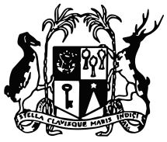

REPUBLIC OF MAURITIUS

MINISTRY OF LABOUR, HUMAN RESOURCE DEVELOPMENT AND TRAINING

Notice to the Public

The Public is hereby informed that due to health hazards following oil spillage in region of Pointe D’Esny, the Mahebourg Employment Information Centre will be temporarily closed until further notice.
Jobseekers are hereby informed that they may call in person or phone at Rose Belle Employment Information Centre, Diocese Lane, Rose Belle on 627-4833.
Jobseekers may also register online and apply for jobs on https://mauritiusjobs.govmu.org.

07 August 2020
Ministry of Labour, Human Resource Development and Training

